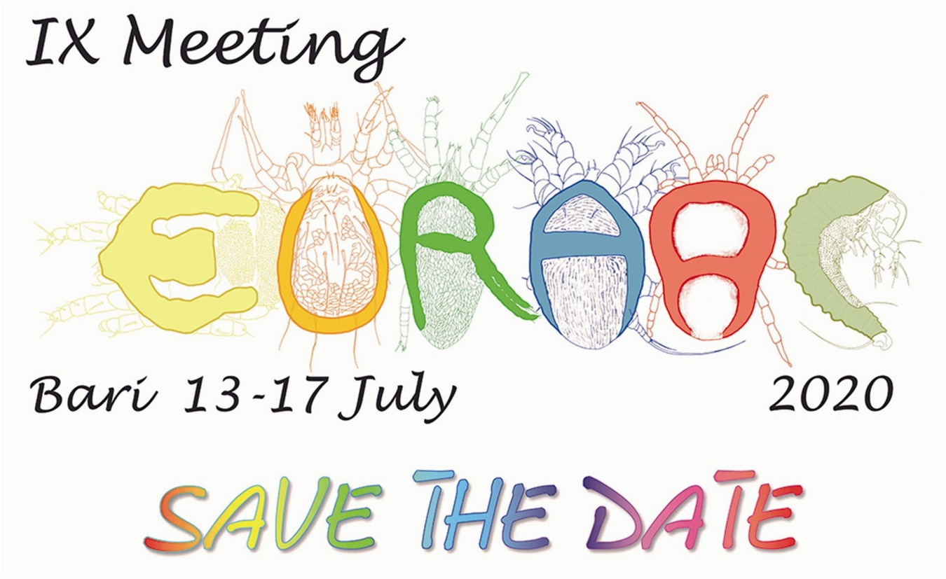
First Communication
Dear Colleagues,
On behalf of the Italian Organizing Committee of the IX EurAAc Symposium, to be held in Bari (Italy) on July 13th-17th, 2020 we have the pleasure to invite scientists, professional from public and private sectors as well as students, graduated and post-graduated people interested in mites and ticks, to attend the symposium.
The proposed topics of the symposium are the following:
Agricultural and forestry acarology
Behaviour, Ecology and Life History Strategies
Biogeography and Biodiversity
Biological Control and IPM
Biological Control of Weeds
Chemical Control, Resistance and Toxicological aspects
Forensic Acarology
Genetics and Biotechnology
Medical and Veterinary Acarology
Morphology and Anatomy
Taxonomy, Systematic and Phylogeny
Your ideas and proposals for organizing further topics or seminars, are welcome.
The Organizing Committee would appreciate your forwarding this first communication to colleagues and societies.
Hoping in your large presence, the Italian Organizing Committee looks forward to welcoming you to Bari.
Further information will follow.
The Local organizer The President of EurAAc
Enrico de Lillo Salvatore Ragusa
University of Bari University of Palermo
enrico.delillo@uniba.it salvatore.ragusadichiara@unipa.it

